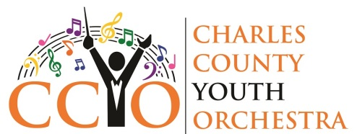
CCYO Summer Chamber Music Camp Application Form
Due: June 15, 2020
Please return this form to Dr. Kivrak at kivrak@yahoo.com
Name:

Address:

Phone:

Email:

Instrument:

Age:

Grade:

School:

Private music teacher:

I have read and agree to abide by the rules below of the CCYO Virtual Chamber Music Camp.
1. Students must be available from 10am-12pm Monday through Friday.
2. No absences are allowed except for medical reasons. Chamber music requires that everyone work together!
3. Students must practice their parts every day and be prepared for each session.
4. Fee of $40 should be paid by July 1 at either the CCYO website: https://www.charlescountyyouthorchestra.org/support or by sending a check to CCYO at PO Box 2569, Waldorf, MD 20604.O
Student Date

Parent (if student is under 18) Date

